June 25, 2024

Devon DuPoy Esquire

Witherite Law Group

901 West Vickery Blvd. Suite 900

Fort Worth, Texas 76104

Tel: (214) 378-6665

RE: *Cory Teschendorf; Sarah Teschendorf et al. v Eric Watkins et al., Case No: DC-23-17383, District Court of Dallas County, Texas, 14th Judicial District*

Date of Crash: January 23, 2023

Date of Birth: *Cory Teschendorf:* September 16, 1985 [37 years old at time of crash]

*Sarah Teschendorf:* September 11, 1986 [36 years old at time of crash]

Dear Mr. DuPoy,

I am in receipt of your correspondence regarding the above-named action. I have reviewed the documentation accompanying your correspondence including medical records, information regarding the subject crash, litigation documents, and other materials.

The purpose of this report is to provide an analysis of the causal relationship between the subject rear impact collision and Mr. and Ms. Teschendorf’s subsequently diagnosed disk injuries and need for treatment.

*My qualifications to provide opinions concerning the matters herein, particularly on issues of the causal relationship between trauma and injury, are as follows:*

I am Professor and Chair of Forensic and Legal Medicine with the Faculty of Forensic and Legal Medicine of the Royal College of Physicians (UK), and a consultant in the fields of forensic medicine and forensic epidemiology. I am credentialed as a Fellow of the Royal College of Pathologists (UK), Fellow of the Faculty of Forensic and Legal Medicine (FFLM) of the Royal College of Physicians (UK) and member of the British Association in Forensic Medicine. I hold the following relevant academic degrees and certifications: a Doctor of Medicine degree (Med.Dr.) from Umeå University, a Doctor of Philosophy (Ph.D.) in public health/epidemiology from Oregon State University, a Master of Public Health (MPH) in epidemiology and biostatistics, also from Oregon State University, a master’s degree in forensic medical sciences (MScFMS) with the Academy of Forensic Medical Sciences in the United Kingdom, i.a. In addition to my degreed education, I have completed a 2-year post-doctoral fellowship in forensic pathology at Umeå University in Sweden and hold a Diploma of Legal Medicine (DLM) with the FFLM. I am also a fellow of both the American Academy of Forensic Sciences and the American College of Epidemiology. I am a Fulbright Fellow and held a 3-year roster appointment (2017-20) with the United States Department of State as a Fulbright Specialist in the field of forensic medicine. I serve as tenured Associate Professor of Forensic Medicine at Maastricht University and a joint Clinical Professor of Psychiatry and Public Health and Preventative Medicine at Oregon Health and Science University School of Medicine, where I have taught courses for the past 24 years in forensic medicine, forensic epidemiology, and injury epidemiology. From 2005-2017 I held an appointment as an Adjunct Professor of Forensic Medicine and Epidemiology at the Institute of Forensic Medicine, Faculty of Health Sciences, Aarhus University, Aarhus, Denmark, and am a recent (2020-21) visiting professor at University of Indonesia in the Faculty of Medicine.

I have been a crash reconstructionist since 1996 and have had ACTAR accreditation (the Accreditation Commission on Traffic Accident Reconstruction) since 2005. Over the past >25 years I have participated in the reconstruction of more than 3,000 crashes, including more than 300 fatalities. From 1999 through 2007 I served as a vehicular homicide investigator for law enforcement (consultant to the state medical examiner and special deputy sheriff), and I am a former affiliate medical examiner with the Allegheny County Medical Examiner’s office.

I am a member of the American Society of Biomechanics and have more than 60 scientific publications pertaining to injury biomechanics, including a book for the Society of Automotive Engineering and taught injury biomechanics in a faculty peer-reviewed course at OHSU for 15 years. I have served as a consultant on injury biomechanics to state and federal government.

I am an associate editor of the Journal of Forensic and Legal Medicine and serve or have served as an associate editor or editorial board member of 14 additional scientific peer-reviewed journals. I have published approximately 230 scientific papers, abstracts, book chapters and books on topics that include traffic crash injuries, crash reconstruction, injury causation and injury biomechanics, including the text for Elsevier, Forensic Epidemiology: Principles and Practice (2016). My publications have been cited by other authors more than 4,900 times.

I have provided testimony in more than 450 civil and criminal trials in state and Federal courts throughout the United States, Canada, and Australia. Please see my CV for further details.

**Background Facts**

On January 23, 2023, at about 11:30 am Cory Teschendorf was the restrained driver of a parked unknown year/make/model truck, with his wife, Sarah Teschendorf as the restrained passenger, in the Costco parking lot located at 3650 W. University Dr., McKinney, Texas, when it was struck on the rear bumper by the rear bumper of a 2018 Toyota Tundra pickup, driven by Erik Watkins, that was backing out of a parking space. No police response occurred. The images below depict overhead satellite and street view images of the crash location and the subject vehicles post-collision:

**Satellite and street view images of approximate crash location**

**(exhibits from Mr. Watkins’ deposition)**

**Teschendorf truck, post-collision**

**Toyota, post-collision**

No damage estimate was provided for the Teschendorf’s truck. The single provided color photo showed damage to the rear chrome/steel bumper and plastic step pad.

No damage estimate was provided for the Toyota for review. The provided single color photo showed damage to the chrome/steel rear bumper and plastic step pad. There also appeared to be misalignment between the left side of the tailgate and the rear of the left side truck box.

*Post-crash history, Cory Teschendorf (driver)*

At the time of the crash, Mr. Teschendorf was sitting stationary in the driver’s seat, with his wife (Sarah Teschendorf), in a Costco parking lot when their vehicle was reversed into by the defendant. On impact, his body jarred forward then backwards. Neither the police nor EMS responded, plans to shop were aborted and they proceeded to the Baylor Scott & White (BSW) Medical Center ED (McKinney), around 1300, where he complained of a mild diffuse headache, and right sided upper back and neck pain. Mr. Teschendorf underwent CT scans of the head and neck, and X-rays of the right upper extremity and lower back. The CT scans were negative for acute intracranial abnormality/acute osseous abnormality, respectively; X-ray of the lumbar spine was also negative for acute osseous abnormality; the right shoulder study revealed a lucent lesion involving the proximal humerus (an MRI was recommended). He was diagnosed with a lower back injury, muscle spasms, right trapezius strain, prescribed Toradol 10 mg, Robaxin 500 mg, and released home.

On January 27, 2023, 4 days after the crash, Mr. Teschendorf returned to the BSW Medical Center ED with complaints of right rib pain and pain in his left knee. He underwent left knee and thoracic spine X-rays which were negative for acute osseous abnormality. Mr. Teschendorf was diagnosed with rib contusion, left knee sprain, and released home.

On February 2, 2023, Mr. Teschendorf presented to True Nguyen PA-C to Dr. Trung Ha (physical medicine and rehabilitation-see prior history) with pain in his bilateral shoulders, neck, and mid to low back. She recommended diagnostic lumbar epidurals, prescribed Mobic and Flexeril and discussed PRP (platelet rich plasma) injections for the left shoulder.

On February 3, 2023, Mr. Teschendorf underwent a telemed consultation with Iqbal Gill NP to Dr. Venkatesh Madhav (internal medicine). He reported pain in his neck, mid to lower back, bilateral shoulders, right elbow, left knee; headache, anxiety and difficulty sleeping. Mr. Gill diagnosed low back pain, thoracic spine pain, bilateral shoulder pain, right elbow pain, left knee pain, insomnia, post-traumatic headache; muscle, and fascia strain of the right rotator cuff, left forearm, cervical/thoracic and lumbar spine. He prescribed codeine/acetaminophen 30/300 mg, methocarbamol 750 mg; recommended chiropractic therapy and referral to orthopedics and neurology with persisting symptoms.

On February 3, 2023, Mr. Teschendorf re-engaged in chiropractic modalities with Dr. Linda Eberendu (chiropractic-refer to prior history) addressing the pain in his neck, mid to lower back, bilateral shoulders, right elbow, left knee and headaches.

On February 10, 2023, Mr. Teschendorf underwent an MRI of the left knee which was negative for acute osseous/ligamentous abnormality.

On February 17, 2023, Dr. Eberendu referred Mr. Teschendorf to pain management. He pursued chiropractic care through April 3, 2023.

On February 20, 2023, Dr. Shaawn Ali (sports medicine-refer to prior history) performed a lumbar epidural steroid injection at L5-S1.

On February 24, 2023, Mr. Teschendorf underwent a telephone consultation with Iqbal Gill FNP due to complaints of worsening pain in his neck and lower back. Mr. Gill provided Mr. Teschendorf with prescriptions for Tramadol 50 mg and Ibuprofen 800 mg.

On March 9, 2023, Mr. Teschendorf presented to Dr. Mark Valente (orthopedic spine surgery) with complaints of neck pain, right arm pain with bilateral arm numbness and weakness, and back pain with bilateral leg pain, numbness, and weakness. He had difficulty picking up small objects. On examination he had decreased sensation in the left lower leg and dorsal left foot, 50% reduction in range of motion in the cervical spine. Dr. Valente recommended updating the cervical and lumbar MRIs to evaluate for nerve impingement; electrodiagnostic testing; physical therapy/home exercises and prescribed Meloxicam 15 mg.

On March 15, 2023, Dr. Ali performed bilateral lumbar facet medial branch blocks at L3-4, 4-5 and L5-S1.

On March 17, 2023, Mr. Teschendorf returned to Iqbal Gill NP with worsening pain in all areas except his right shoulder, which was improving slowly. He was advised to return to clinic as needed.

On March 28, 2023, Dr. Ha performed left lumbar facet medial branch nerve radiofrequency ablations. Mr. Teschendorf received acetaminophen-codeine 300-30 mg for severe post-procedure pain.

On April 4, 2023, Dr. Ha performed right lumbar facet joint injections at L3-4, 4-5 and L5-S1.

On April 17, 2023, True Nguyen PA-C recommended undergoing cervical facet joint injections, bilaterally, one week apart.

On May 2, (and 9) 2023, Dr. Ha performed bilateral cervical facet joint injections at C4-5, 5-6 and 6-7.

On May 5, 2023, Mr. Teschendorf presented to Dr. Kyle Stuart (orthopedic surgery) with left knee pain exacerbated by the subject crash, and left shoulder pain. Dr. Stuart diagnosed patellofemoral syndrome, left shoulder SLAP tear, and discussed treatment options to include diagnostic arthroscopy for the left knee with possible chondroplasty; and left shoulder arthroscopic surgery and biceps tenodesis with persisting symptoms.

On June 13, 2023, Dr. Ha performed bilateral sacroiliac joint injections.

On July 25, and August 2, 2023, Mr. Teschendorf underwent bilateral sacroiliac joint radiofrequency ablations, performed by Dr. Ha (providing more than 90% relief).

On August 18, 2023, Dr. Ha recommended cervical RFAs (radiofrequency nerve ablations) at C4-7.

On September 13, and 20, 2023, Mr. Teschendorf underwent bilateral cervical facet medial branch block injections at C4-7 providing partial short-term symptom improvement.

On September 27 and October 4, 2023, Mr. Teschendorf underwent bilateral C4-5, 5-6 and 6-7 facet joint medial branch radiofrequency nerve ablations, performed by Dr. Ha. Additionally, Mr. Teschendorf was referred to orthopedic spine for consultation. Height: 5 ft 8 inches, weight: 219 lbs.

*Pre-crash medical history*

Mr. Teschendorf underwent left knee surgeries in 2007 and 2009.

In 2018, Mr. Teschendorf was in a traffic crash which resulted in neck, lower back, and left shoulder complaints for which he underwent a period of physical therapy.

On July 16, 2021, and September 22, 2022, Mr. Teschendorf was involved in further traffic crashes. Prior to both incidents he had mild neck pain with numbness in the ulnar aspect of both arms and hands and mild back pain (resulting from military service). Mr. Teschendorf received cervical (x1) and lumbar (x 2) epidural steroid injections after the first crash which improved his symptoms. The second crash exacerbated pain in his neck, lower back pain and left wrist; and he had a severe headache. He was evaluated at the Texoma Medical Center ED on September 25, 2022, where he was diagnosed with post-concussive syndrome, closed head injury, cervical spine strain, left wrist and left knee sprains.

On October 6, 2022, through January 25, 2023 (2 days after the subject crash) Mr. Teschendorf underwent therapeutic modalities with Dr. Linda Ebernedu (chiropractic).

On October 12, 2022, Iqbal Gill NP referred Mr. Teschendorf to neurology secondary to complaints of headaches, dizziness, tinnitus, pain behind his eyes, nausea, difficulty sleeping, bilateral arm/hand tingling and numbness, bilateral leg/foot tingling and numbness, neck pain radiating to both shoulders, and upper and lower back pain radiating to both legs.

On October 25, 2022, Mr. Teschendorf underwent MRI studies of the bilateral shoulders. The right shoulder revealed: prior rotator cuff repair, chronic tear of the labrum; the left shoulder revealed: low grade interstitial tearing of the subscapularis tendon, and non-displaced tear of the superior labrum.

On October 27, 2022, Mr. Teschendorf presented to Dr. Linda Eberendu (chiropractic) to re-establish care. Further treatment modalities were initiated for radiating neck pain, mid to low back and left shoulder pain. She recommended re-evaluating after 3-4 weeks.

On October 28, 2022, Mr. Teschendorf underwent bilateral shoulder, cervical and lumbar spine MRIs. The shoulder MRIs revealed: bilateral low grade partial distal tear in the subscapularis tendon and mild to moderate rotator cuff tendinopathy.

The cervical spine study revealed: at C6-7, a 4 mm broad posterior disk osteophyte complex, central canal narrowed to 7 mm, moderate to severe bilateral foraminal stenosis; at C5-6, 2 mm disk osteophyte complex with moderate left foraminal narrowing; at C3-4, 1-2 mm disk herniation.

The lumbar spine MRI revealed: multilevel facet arthrosis and 1-2 mm disk bulge in conjunction with prominent epidural fatty deposition resulting in narrowing of the thecal sac to 8-9 mm from L1-2 through L5-S1 level; 25% narrowing at L3-4, 4-5 and L5-S1.

By the end of October 2022, Mr. Teschendorf’s pain had become more concentrated on the right side (right neck, mid and lower back; right rib pain). He also started getting left wrist pain.

On November 4, 2022, Mr. Teschendorf underwent consultation with Dr. Chaitanya Bonda (neurology). He had daily headaches (Dr. Bonda noted multiple concussions, some associated with a loss of consciousness) requiring 1800 mg Ibuprofen which occasionally helped. Associated symptoms included photophobia, phonophobia, constant tinnitus and nausea, difficulty sleeping, irritability and fatigue, memory issues and some confusion. Dr. Bonda diagnosed concussion, acute post-traumatic headache, mild cognitive impairment, cervicalgia, low back pain, lumbar radiculopathy, and insomnia. Dr. Bonda ordered an electroencephalogram (EEG) to evaluate for seizure activity, and electromyography/nerve conduction velocity (EMG/NCV) studies of the bilateral upper and lower extremities to evaluate for radiculopathy versus focal nerve entrapment. He prescribed amitriptyline 50 mg.

On November 10, 2022, Mr. Teschendorf underwent the EMG/NCV studies which evidenced mild bilateral carpal tunnel syndrome and a possible small fiber sensory neuropathy in the bilateral lower extremities.

Mr. Teschendorf underwent right shoulder rotator cuff surgeries x 5, the last being on November 17, 2022 (he was treating with VA for his right shoulder).

On December 7, 2022, Mr. Teschendorf underwent further MRI studies of the cervical, thoracic, and lumbar spine. The cervical spine revealed: at C5-6, 3 mm disk protrusion, moderate left foraminal stenosis; at C6-7, 3 mm disk bulge, severe foraminal stenosis.

The thoracic spine revealed: at T11-12, disk extrusion with severe right foraminal stenosis; at T9-10 moderate foraminal stenosis.

The lumbar spine revealed: at L4-5, 3 mm disk bulge with moderate foraminal stenosis and at L5-S1, 4 mm disk bulge.

On January 12, and 19, 2023, 4 days prior to the subject crash, Mr. Teschendorf underwent diagnostic bilateral L3-4, 4-5 and L5-S1 facet joint injections with Drs. Shawn Ali and Trung Ha (interventional pain management).

On January 20, 2023, 3 days before the subject crash, Mr. Teschendorf underwent an MRI of the left knee which revealed: distal quadriceps tendon signal abnormality at the insertion on the upper pole of the patella (typical of tendinitis) and partial thickness interstitial tearing.

*Medical and other records reviewed for history*

Quantum Pain & Sports Medicine (prior/post), Drs. Ali/Ha

DFW MRI

Texas Healthcare Neck and Back Clinics (prior/post), Dr. Eberendu

Trusted Medical Providers (prior/post), Iqbal Gill FNP

Merge Health, Dr. Valente

Baylor Scott & White Medical Center ED

Touchstone Imaging

Texoma Medical Center ED (prior 2022 crash)

Lone Star Neurology (prior), Dr. Bonda

Dr. Stuart, records

*Post-crash history, Sarah Teschendorf (front passenger)*

At the time of the crash, Ms. Teschendorf was sitting stationary in the front passenger seat of the vehicle, next to her spouse (the driver-Cory Teschendorf), in a Costco parking lot. On impact, her body jarred forward then backwards. Neither the police nor EMS responded but she, and her spouse, proceeded to the Baylor Scott & White (BSW) Medical Center ED (McKinney), around 1300, where she complained of headache, right sided neck and lower back pain and right hip pain.

Ms. Teschendorf underwent CT scans and X-rays of the lumbar spine, cervical spine, and head which were negative for acute osseous abnormality/intracranial abnormality, respectively. She was diagnosed with trapezius muscle strain, prescribed Toradol and Robaxin, and released home.

On February 3, 2023, around 10 days after the crash, Ms. Teschendorf underwent a telemedicine consultation with Iqbal Gill NP to Dr. Verkatesh Madhav (internal medicine). She reported neck pain, mid to low back pain, right hip pain and headache. She also had difficulty sleeping. Ms. Teschendorf underwent X-rays of the right hip, right shoulder, cervical and lumbar spine which were negative for fracture. Mr. Gill diagnosed cervicalgia, thoracic and lumbar spine pain, right hip pain, post-traumatic headache, insomnia and muscle, fascia and tendon strains of the neck, thorax, and lower back. He prescribed Methocarbamol 750 mg, Ibuprofen 800 mg and recommended chiropractic therapy.

On February 3, 2023, through April 3, 2023, Ms. Teschendorf underwent chiropractic therapy at Texas Healthcare Neck and Back.

On February 17, 2023, Ms. Teschendorf presented to Dr. Shaawn Ali (pain and sports medicine). She had persistent pain in her right hip, pelvic pain, diffuse headache (with associated ringing in her ears, forgetfulness and phonophobia), pain in her neck intermittently radiating down her right arm with associated numbness and tingling, and persistent pain in her mid to lower back. Dr. Ali diagnosed right sacroiliitis, right hip contusion, cervicalgia, cervical/thoracic and lumbar spine pain, post-traumatic headache, tinnitus, abnormal gait, pelvic and perineal pain, adjustment disorder with anxiety, and bilateral hyperacusis. Dr. Ali ordered MRI studies of the lumbar spine and pelvis, referred Ms. Teschendorf to ENT and prescribed Voltaren gel.

On February 24, 2023, Ms. Teschendorf underwent follow up telemedicine evaluation with Iqbal Gill NP. The neck pain and headaches were gradually improving but she had persistent pain in her mid, lower back and right hip. She was encouraged to continue therapy and follow up as needed.

On March 9, 2023, Ms. Teschendorf underwent an MRI of the pelvis which was negative for acute osseous/ligamentous abnormality.

On March 9, 2023, Ms. Teschendorf presented to Dr. Mark Valente (orthopedic spine surgery) with persistent pain in her neck and back (8/10-refer to pre-crash history), and complaints of pain in her right knee. Dr. Valente prescribed Mobic 15 mg, home directed physical therapy, ordered MRIs of the cervical and lumbar spine to evaluate for neural impingement and an MRI of the right knee to evaluate for internal derangement.

On March 17, 2023, Ms. Teschendorf underwent the cervical, lumbar and right knee MRIs. The cervical spine MRI revealed: mild posterior disk bulges at C3-4 through C7-T1 with the disk protrusions largest at C4-5 and 5-6 (2 mm); and an 8 x 5 mm subcutaneous nodule in the right posterior lateral neck at C3-4 possibly representing a small lymph node.

MRI of the right knee revealed an 11x 7 mm ganglion cyst of the proximal medial head of the gastrocnemius tendon, and multifocal cartilage fissure in the medial patella.

On April 4, 2023, Ms. Teschendorf returned to Dr. Ali with persistent pain, more so in the right hip. Dr. Ali recommended a steroid injection for the right sacroiliac joint.

On May 4, 2023, Dr. Ali performed a right sacroiliac joint steroid injection.

On May 11, 2023, Dr. Valente referred Ms. Teschendorf to pain management for the consideration of cervical and lumbar epidural steroid injections. She was advised to follow up with Dr. Valente as needed.

On June 9, 2023, Dr. Ali performed a right sacroiliac (SI) joint lateral branch nerve diagnostic block followed by a right SI joint lateral branch nerve radiofrequency ablation on June 14, 2023.

On July 18, 2023, Ms. Teschendorf revisited Dr. Ali. She had persistent (but improving) pain in her right hip and persistent pain in her lower back. Ms. Teschendorf wished to concentrate on treating the lower back at this point. Dr. Ali ordered lumbar spine X-rays prior to discussing treatment options. Height: 5 ft 3 inches, weight: 125 lbs.

*Pre-crash medical history*

Ms. Teschendorf underwent a prior L1-3 lumbar fusion for scoliosis in 2002 (with left thoracolumbar flank incision). She was asymptomatic until she was involved in a traffic crash on July 16, 2021, where she sustained pain in her neck and back. She underwent physical therapy and received epidural steroid injections which reduced the pain significantly to only mild symptoms. However, Ms. Teschendorf was in a further traffic crash on September 22, 2022, which exacerbated the pain in her neck and back. She underwent additional physical therapy and received further epidural injections with symptom improvement with only mild symptoms (4/10) from around 3 months prior to the subject crash.

Ms. Teschendorf underwent an MRI of the cervical spine on October 28, 2022, which revealed: 1-2 mm disk herniations at C4-5 and 5-6.

On November 4, 2022, Ms. Teschendorf was evaluated by Dr. Chaitanya Bonda (neurology) due to complaints of dizziness and headaches following the September 2022 crash. She was diagnosed with concussion, acute post-traumatic headache, mild cognitive impairment, cervicalgia, cervical radiculopathy, low back pain, lumbar radiculopathy, and insomnia; referred for electrodiagnostic studies of the bilateral upper and lower extremities and encouraged to follow up with ortho spine.

On November 10, 2022, Ms. Teschendorf underwent the bilateral upper/lower EMG/NCV studies which revealed: normal electrodiagnostic study with a possible fiber sensory neuropathy (lower extremities).

*Medical and other records reviewed for history*

Trusted Medical providers, Iqbal Gill NP (prior/post)

Merge Health Pain and Orthopedic, Dr. Valente

MRI Centers of Texas, MRI pelvis

Baylor Scott & White Medical Center ED

Envision Imaging, MRIs

Texas Health Care Neck and Back, chiropractic (prior/post)

Lonestar Neurology, Dr. Bonda (prior)

DFW MRI (prior)

Cory Teschendorf’s First Set Of Interrogatories

Sarah Teschendorf’s First Set Of Interrogatories

Plaintiff’s First Amended Petition And Jury Demand

Deposition transcript of Eric Watkins with exhibits (March 28, 2024)

Cory Teschendorf’s Baylor Scott & White-McKinney medical records

Sarah Teschendorf’s Trusted Medical Providers and Merge Health medical records

1-color photograph .pdf file of Plaintiff’s vehicle

1-color photograph .pdf file of Defendant’s vehicle

***Injury Causation Analysis***

A crash-related injury causation analysis for a specific individual is performed by assessing the risk of injury from the collision and comparing it to the probability that the injuries or conditions would have been present at the same point in time if the collision had not occurred. The process is referred to as a "3-step" injury causation method in which improbable alternative causes are ruled out and the single most likely cause is identified. The analysis is accomplished via the application of crash reconstruction, biomechanical, medical, and epidemiologic (risk assessment) principles.[1],[2] This 3-step methodology has been extensively described in the peer-reviewed literature, been deemed generally accepted by Courts in the United States, and has been adopted as part of case law in the U.S.[3],[4] See the Appendix at the end of this report for more information.

The three fundamental elements or steps of an injury causation analysis are as follows:

1. Whether the injury mechanism had the potential to cause the injury in question (aka general causation);

2. The degree of temporal proximity between the injury mechanism and the onset of the symptoms reasonably indicating the presence of the injury; and

3. Whether there is a more likely alternative explanation for the occurrence of the symptoms at the same point in time (aka differential etiology).

As applied to the facts in the subject case, these 3 steps are as follows:

*Injury mechanism: reconstruction of the crash, injury biomechanics*

*Reconstruction:*

The weather and parking lot surface conditions as seen in the two provided color photos indicated it was daylight and dry and Mr. Watkins testified it was sunny. There was no speed limit information for the parking lot provided.

No deposition of Mr. Teschendorf was provided. In his First Set Of Interrogatories, he stated that he and his wife were parked in the Costco parking lot making plans and he was leaned over talking to her, with his weight on his right shoulder, when Mr. Watkins reversed his Toyota while trying to leave and struck their parked vehicle. The impact, which was unexpected, pushed their vehicle forward against the large rubber stoppers that were positioned in front of the disabled persons parking spaces. The rubber stoppers pushed their vehicle rearward, and they struck the Toyota. Mr. Watkins appeared to be fleeing from the scene, so he exited his vehicle and in doing so he twisted his back. In his Baylor Scott & White Medical Center ED records (January 23, 2023) he told medical providers that he was the restrained driver of a parked car that was rear ended by another vehicle at low speed and he was jarred forward and backwards.

No deposition of Ms. Teschendorf was provided. In her First Set Of Interrogatories, she stated that she and her husband were parked in the Costco parking lot when Mr. Watkins reversed his Toyota while trying to leave and struck their vehicle, pushing it forward into the rubber stoppers. Their vehicle bounced back and was struck by the Toyota again. In her Merge Health medical records (March 9, 2023) she told medical providers that she was a restrained passenger in a stopped vehicle that was rear-ended.

Mr. Watkins, deposed on March 28, 2024, testified that his Toyota was parked in a regular parking space that was pretty close to Costco’s entrance, adjacent to a curb, and he had entered it to leave. He started it up, glanced at his rearview mirror, and maybe one sideview mirror, and began to back up. His Toyota had a backup camera, and the viewing monitor was on the center rearview mirror. He initially backed out straight so he wouldn’t hit the car next to him or the curb. Then he started to cut the steering wheel and was tapping the brake pedal while he was still backing up. He was just about to put the Toyota into drive to pull forward when he felt a bump like he hit something. He only felt one impact. He pulled back into the parking space and got out to see what he hit. He saw that he had hit the truck that was across the way from him, and a man was there looking at him and the bumper that he had hit. The Toyota did not have any modifications to it to be used for his business, but it did have a ball type trailer hitch that did not appear to have made contact with the other truck. His Toyota had damage related to the subject crash on the rear bumper and the lower edge of the tailgate. The damage to the tailgate occurred the first time he opened it after the crash and was due to the tailgate being out of alignment from the impact. He did not have any repairs done to his Toyota due to the crash. The only damage he saw to the Teschendorf’s truck was on the left side of the rear bumper.

*Analysis:*

The Teschendorf’s vehicle was a rental vehicle and from the photo it appears to be a newer 2019-2022 Chevrolet Silverado 1500 bumper. The right rear corner of the Toyota impacted the Chevrolet bumper laterally about ⅓ from the left side. More than likely the Toyota was backing out counterclockwise (animated below):

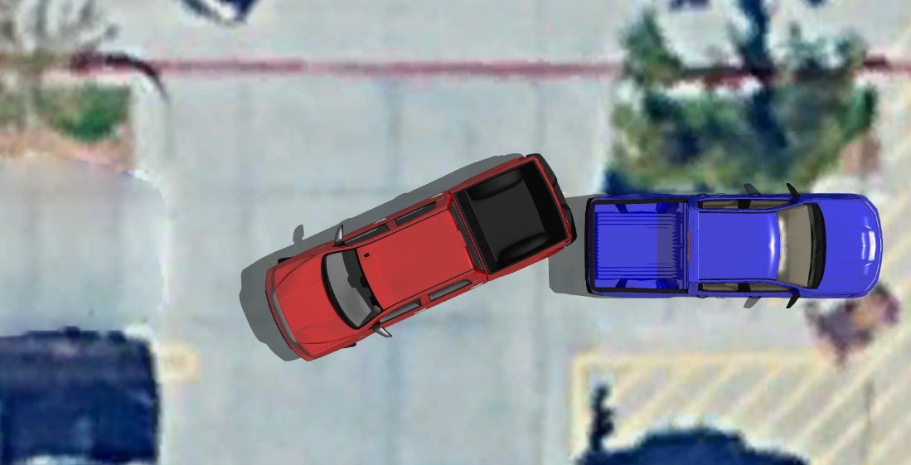

**Animated pre-impact positions, Toyota in red, as it is backing out of the stall across from the Teschendorf Chevrolet**

Deformation in the subject vehicles appear to 1-2+ inches with the Toyota bumper deforming sufficient to cause damage to body parts. A widely used crash simulation program[5] is capable of modeling deformation and depth of penetration or maximum engagement during a collision. By overlapping the damage between scale models of the Toyota and the Chevrolet as observed in the photos, I can model the subject crash to determine a closing speed estimate, which will in turn, estimate an approximate speed change or delta V imparted to the Chevrolet in the crash by using a momentum, energy and restitution (MER) analysis, and then matching these results to the physical and other evidence.

An impact speed of 5 mph from the Toyota would have resulted in a delta V in the Chevrolet of approximately 3.2 mph, with a peak vehicle acceleration for the impact of approximately 1.9 g. Deformation (overlap or depth of penetration) between the Toyota and the Chevrolet is shown below and is fairly consistent with what is observed in the photos.

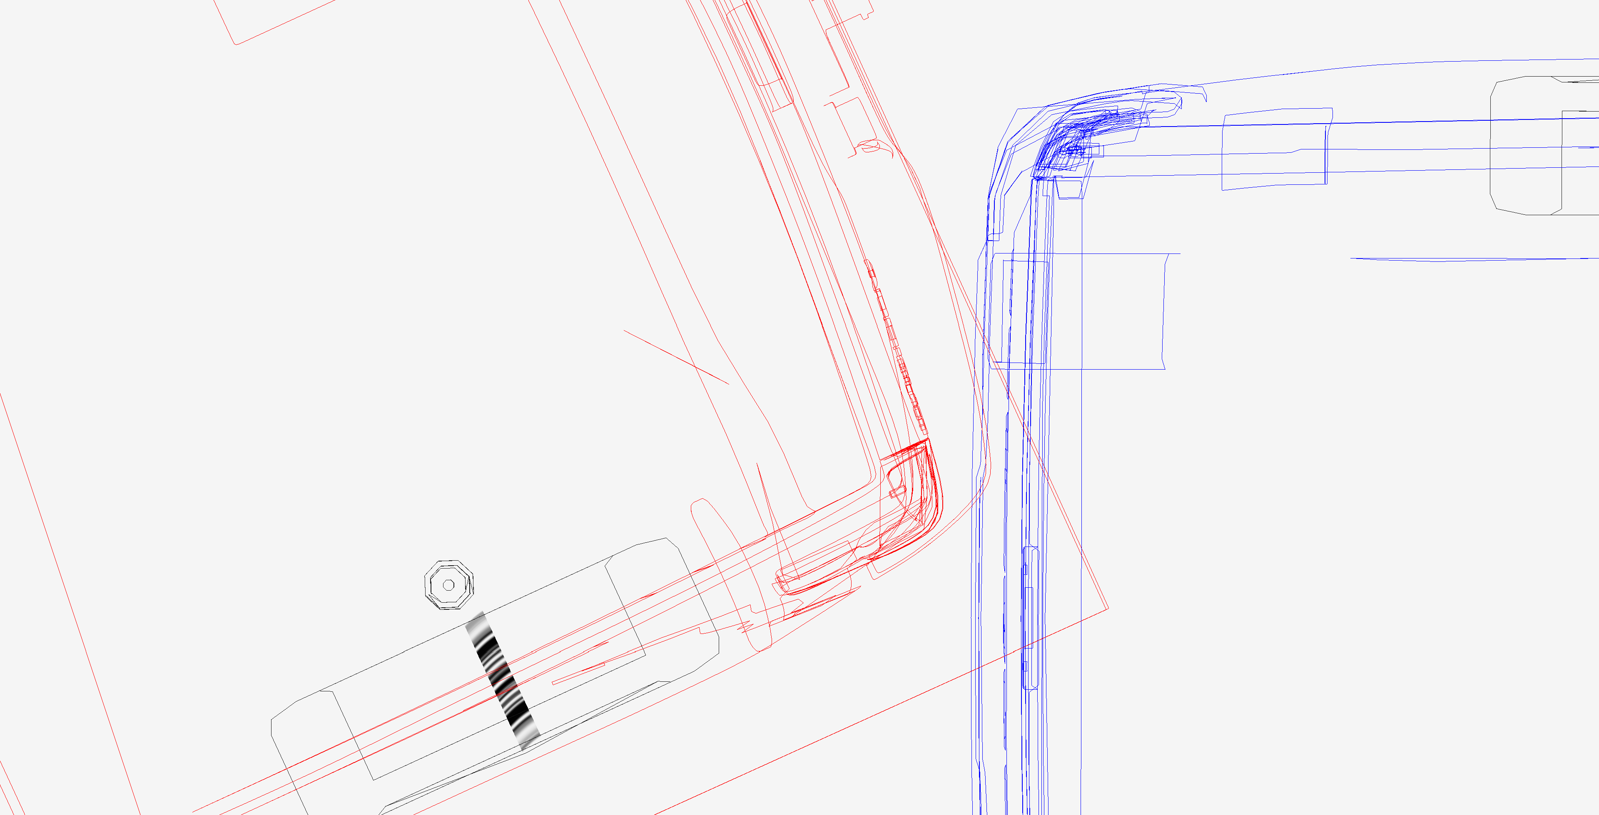

**Simulated 5 mph depth of penetration (overlap or maximum engagement) is fairly consistent with photos. Teschendorf’s Chevrolet is the vehicle on the right in blue.**

Even though this impact was minor, the impact with rubberized curb stopper would have been around 3.2 mph and because the tires are air filled rubber impacting another rubber object, the restitution (the tendency to rebound) would have been high (estimated 50-90%). The impact with the curb stopper likely caused a delta V of 4.8 – 6 mph in the Toyota and a delta V of 1.8 – 2.2 mph when it collided into the Toyota again. The changes in direction for the Chevrolet occupants would have been sudden and relatively violent; Relative to the interior of the Teschendorf’s vehicle, first rearward, then forward as it impacted the curb bumper, followed by more forward acceleration as it rebounded off the curb bumper and rearward again as it impacted the Toyota a second time. All occurring with 0.2-0.3 seconds depending on the relative positions of the vehicles.

*Injury biomechanics*

The rear impact would have resulted in Mr. and Ms. Teschendorf’s torsos and heads initially being thrown rearwards into the seatback at around 3.2 mph, and then rebounding forward into the restraining seat belt and toward the steering wheel (the first part of the crash kinematics that they ). they would have sustained substantial complex loads on their spines in the collision, loads that include compression, rotation, and shear all occurring at the same time and to varying degrees in less time than it takes to blink an eye (around 250 msecs).

The National Highway Traffic Safety Administration (NHTSA) has published injury risk curves for rear impact crashes, demonstrating a rate of minor or greater “MAIS 1+” (Maximum Abbreviated Injury Scale injury severity grade of 1 or more) injuries, nearly all requiring an emergency department visit, of 17% for a 3.2 mph delta V rear impact collision (see the blue arrow in the chart below). Approximately 94% of spinal disk injuries would be included in this category of injuries, as this is the rate at which disk injuries are initially diagnosed as strains (i.e., MAIS 1 [minor injuries]) in the emergency department in the first day or 2 after a crash, which is the source of the NHTSA data. There is also an approximately 0.3% chance of an immediately apparent more serious injury, including fracture, organ injury, or intracranial bleeding, etc. in a low speed rear impact crash of the same severity (see the red arrow in the chart below).

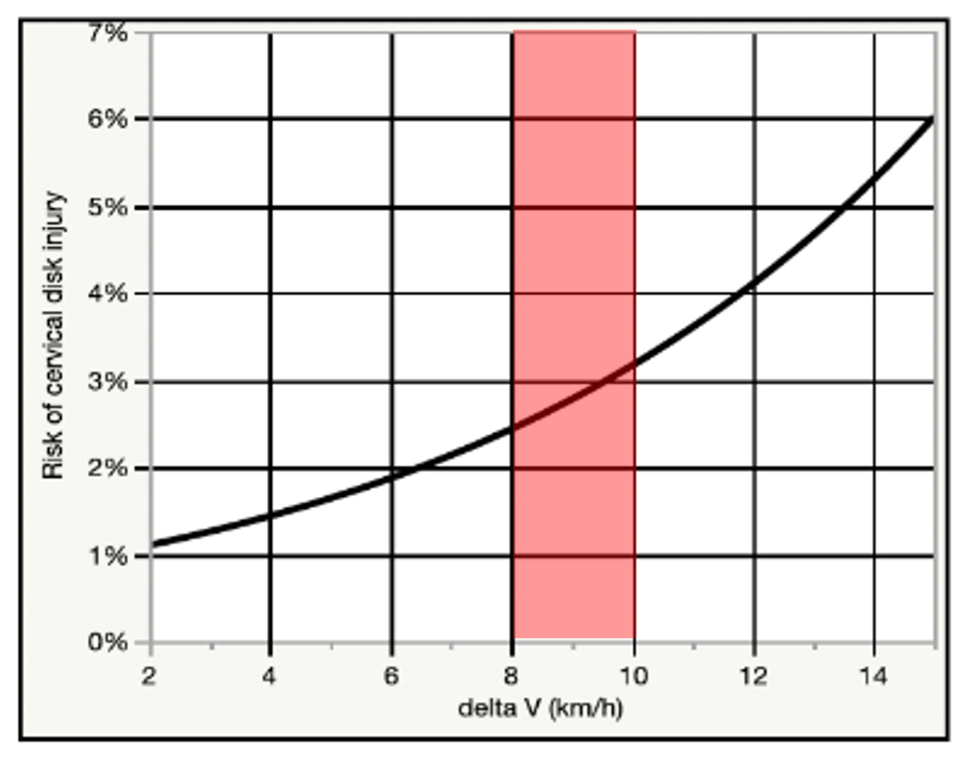

Chart showing the relationship between a ~5 to 6 mph delta V (red band) rear impact and cervical disk injury risk observed in 113 people exposed to real-world crashes. As demonstrated in the chart, the risk of a cervical disk injury ranges from 2.5 to 3.3%, or around 1 in 40 to 1 in 30 in such a crash. The risk to the low back is approximately 60% that of the risk to the neck. *Note:* 5 to 6 mph is approximately equal to 8 to 10 km/h on the chart.

Discussion

The types of spinal injuries that Mr. and Ms. Teschendorf were diagnosed with (primarily chronically symptomatic disk derangements) are highly consistent with the injury mechanism of the crash. Traumatic loading of the spine that results in axial (up and down) compression, particularly in combination with the other load types occurring with the subject collision, has the potential to damage the peripheral disk annulus, which surrounds and holds in the disk nucleus. Men in their late 4th decade, like Mr. Teschendorf (who was 37 at the time of the crash) typically have at least moderate age-related degenerative changes of the disks of the spine, a fact that makes the post-crash findings in Mr. and Ms. Teschendorf’s imaging reasonably a combination of post-traumatic overlaying degeneration, as opposed to solely due to either trauma or pre-existing degeneration.

The symptoms of spinal disk injury may, in some cases, be instantly recognizable after a traffic crash because of the sudden onset of radiculopathy, but recent research has demonstrated that only about 1 in 17 cervical disk injuries are recognized as such in the ED after a crash.[6] By far, the majority (94%) of what are later determined to be spinal disk injuries are initially diagnosed as in the ED as spinal strains.

Although the subject crash was no "bumper tap" it is well established in science and medicine that an excessive level of force is not required to cause symptomatic injury to a degenerated disk, and that in most cases, the diagnostic imaging of the disk will not reveal whether related symptoms are of a traumatic origin or not, in the absence of fracture.[7] Traumatic disk injuries have been described in the peer-reviewed literature as resulting from low to moderate force events, including minimal or no damage traffic crashes, roller coaster rides, and even more mild forces such as sneezing.[8]-[9][10][11][12][13][14] It is accurate to state that there is no established or generally accepted lower force threshold at which it can be said that an acute intervertebral disk injury in any part of the spine cannot occur.

Based on the preceding discussion there was ample and biomechanically appropriate force exerted on Mr. and Ms. Teschendorf’s bodies in the subject collision to have caused their medically documented injuries, and associated need for evaluation and treatment, including their spinal pain management procedures, etc.

**Temporal relationship between the crash and symptoms indicative of injury**

The second step of the injury causation analysis is the assessment of the timing between the trauma and the onset of symptoms indicative of injury. The hallmark of injury is that "you know it when it happens;" *i.e.* the causal relationship between the trauma and onset of the symptoms indicative of the injury is usually close enough in time that it is easy to recognize when the injury was incurred. There are some injuries that exhibit a delayed onset of symptoms, including injuries to intervertebral disks, which can first manifest with identical symptoms to a simple spinal strain. Other injuries are always immediately apparent, such as bony fractures. Some injuries are considered "distracting" from others because the pain they generate distracts attention from other, less painful injuries. There are still other injuries that can "mask" pain from nearby parts of the body through complicated pain accommodation mechanisms that are mediated at the spinal cord and in the brain. The assessment of the timing of the onset of symptoms reasonably attributed to an injury can sometimes be nuanced and complicated, and sometimes requires expert assessment.

Mr. Teschendorf experienced the onset of symptoms indicative of acute spinal injury immediately after the crash, and they were diagnosed with neck and back injuries directly by 3 days following the crash, including the presentation of lower extremity radicular symptoms, an ominous early sign of injury to the intervertebral disks in the spine. The symptoms and diagnoses progressively evolved and worsened over the weeks and months following the crash and demonstrate a well-documented contiguous chain of causation linking the subject crash and Mr. and Ms. Teschendorf's diagnosed low back and cervical spinal injuries, and associated need for treatment.

Based on this history, there was a strong temporal relationship between the subject collision and Mr. and Ms. Teschendorf’s first development of symptoms indicative of spinal injury.

**Alternative explanations**

This last step of the injury causation analysis specific to the individual involves the assessment of the probability of the same symptoms, injuries, diagnoses, and need for treatment occurring at the same point in time, but in the absence of the investigated crash.

This part of the analysis is accomplished in 2 ways; first and most obviously, any competing contemporaneous traumatic cause of injury must be ruled out. There is, however, no such history for Mr. or Ms. Teschendorf, and the only source of trauma apparent in my review of materials that is temporally proximate to their post-crash injuries is the January 23, 2023, low speed rear impact crash.

The second part of the analysis requires an assessment of the probability that Mr. or Ms. Teschendorf would have developed the symptoms and diagnoses of spine injury at the same point in time had they not been initially injured in the January 23, 2023, rear impact crash. As a generally healthy 37-year-old male, Mr. and Ms. Teschendorf was at a negligible annual risk of spontaneously developing chronically painful and potentially surgical cervical or lumbar spinal disk derangements; less than 1 in 2,000 is indicated by epidemiologic study and national hospital data.[15] The chance that theywere going to develop the onset of chronic neck or low back pain attributable to symptomatic disk derangements on the same day as the crash by pure coincidence is obviously much smaller; less than 1 in 730,000 (the annual risk divided by 365 days). In comparison the risk of any acute spine injury in the subject crash was likely more than 50%, and the risk of a spinal disk injury was likely no less than 1 in 25 in the general population.[16] Based on this comparison of risk during the timeframe of interest, the crash is the most likely cause of Mr. and Ms. Teschendorf’s chronic spinal injuries by >99%.The second part of the analysis requires an assessment of the probability that Mr. or Ms. Teschendorf would have developed the symptoms and diagnoses of spine injury at the same point in time had they not been initially injured in the January 23, 2023, rear impact crash. As a generally healthy 36-year-old male, Mr. and Ms. Teschendorf was at a negligible annual risk of spontaneously developing chronically painful and potentially surgical cervical or lumbar spinal disk derangements; less than 1 in 2,000 is indicated by epidemiologic study and national hospital data.[17] The chance that theywere going to develop the onset of chronic neck or low back pain attributable to symptomatic disk derangements on the same day as the crash by pure coincidence is obviously much smaller; less than 1 in 730,000 (the annual risk divided by 365 days). In comparison the risk of any acute spine injury in the subject crash was likely more than 50%, and the risk of a spinal disk injury was likely no less than 1 in 25 in the general population.[18] Based on this comparison of risk during the timeframe of interest, the crash is the most likely cause of Mr. and Ms. Teschendorf’s chronic spinal injuries by >99%.

A relatively common medicolegal question is whether persisting symptoms of back or neck pain after a traffic crash are truly related to the crash, or more probably due to other factors incidental to an acute crash-related injury to the spine. Most typically, the "other factors" that are raised in a medicolegal setting are the presence of pre-existing degenerative changes in the spine, or pre-crash history of low level or sporadic symptoms.

The answer to this question is now decided science. Along with my research colleagues, I have recently published 2 analyses and systematic reviews of nearly 10,000 articles regarding the long-term effects of traffic crash-related injury to the neck and low back and associated chronic pain.[19],[20] Systematic reviews are considered the most reliable and strongest form of scientific evidence (i.e. Level I evidence), as they consist of a comprehensive synthesis of world literature on a topic.[21] The result of the analyses indicate that when men like Mr. and Ms. Teschendorf have persisting neck or back pain after an acute crash-related injury, *more often than not* (>50% of the time) the symptoms are due to the crash, versus all other causes, regardless of pre-crash medical history.

**Conclusions**

Given the contiguous chain of causation from the day of the crash through Mr. and Ms. Teschendorf’s most recent medical records, the lack of any significant pre-crash history of persisting spine pain and need for treatment in the years prior to the crash, as well as the relative risk of significant and persisting spine injury from the subject frontal impact crash, I conclude that the most probable cause of the post-crash acute and chronic neck and low back injuries described in Mr. and Ms. Teschendorf’s medical records and summarized in this report, including their symptomatic cervical and lumbar disk derangements, is the subject January 23, 2023, low speed rear impact crash.

I have examined neither Mr. nor Ms. Teschendorf and I therefore have no opinions about their diagnoses, treatment, or prognoses outside of what is reflected in the medical record. This is not to say that I am not qualified, licensed, and extensively experienced in performing such evaluations, but that I have not done so in this case.

The preceding opinions were given as reasonable medical, and scientific probabilities. I reserve the right to amend any of my opinions should new information come to light.

Very truly yours,

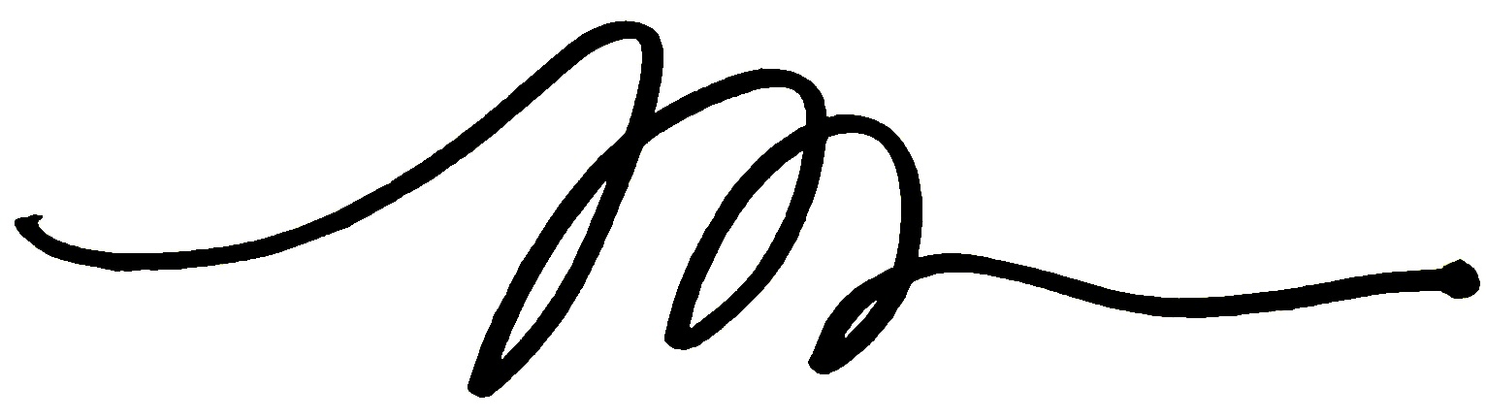

Michael D. Freeman, MedDr, PhD, MScFMS, MPH, FRCPath, FFFLM, FACE, DLM

**David Jenkins Memorial Professor and Chair in Forensic and Legal Medicine**  
Faculty of Forensic and Legal Medicine, Royal College of Physicians (London, UK)  
  
**Associate Professor of Forensic Medicine,**  
Care and Primary Healthcare Research Institute, Faculty of Health, Medicine, and Life Sciences, Maastricht University, Maastricht, Netherlands  
  
**Clinical Professor of Forensic Psychiatry**  
Department of Psychiatry, School of Medicine, Oregon Health & Science University  
  
Fellow, Royal College of Pathologists (UK)  
Fellow, Faculty of Forensic and Legal Medicine, Royal College of Physicians (London, UK)  
Fellow, American College of Epidemiology  
Member, American Society of Biomechanics

**Appendix**

The 3-step causation methodology that I have used in this case is set forth in a number of my peer-reviewed publications, including a paper entitled *A Systematic Approach to Clinical Determinations of Causation in Symptomatic Spinal Disk Injury Following Motor Vehicle Crash Trauma*, published in the Journal of Physical Medicine & Rehabilitation in 2009. I first described this 3-step methodology in a paper published in 2008 and have since published more than a dozen papers describing some of the manifold applications of the causation methodology. As I describe below, the 3-step causal methodology has recently become part of United States Appellate Court case law on injury causation.

The methodology set forth in my 2009 paper consists of 3 steps or elements that need to be satisfied in an injury causation analysis in order to conclude that an injury resulted from a particular event to a reasonable degree of medical/scientific probability, which are as follows:

1. Plausibility: This first step addresses whether it is biologically *possible* for the injury event to have caused the condition (a.k.a general causation). A finding of plausibility is unrelated to the *frequency* of the injury, because even if the injury occurs in only 1 in 100 or fewer cases of exposure to the event (e.g. a spinal disk injury following a car crash), it is still *plausibly* caused by the event. Plausibility is a relatively low hurdle to clear in a causal analysis and is largely satisfied by the lack of evidence of *implausibility* of the relationship. Although it is common in crash injury litigation for the defendant to assert minimal vehicle damage as a basis for disputing injury causation, the approach is unhelpful for evaluating plausibility, as such an analysis does not have a sufficiently low error rate to establish impossibility, and at best can only be used to suggest a low frequency of injury in the general population. An example of an *impossible* causal relationship is the discovery of leukemia the day after a crash, as it is well established that it is not biologically plausible for trauma to cause leukemia. Plausibility is often, but not necessarily, established with epidemiologic data or information.

2. Temporality: This second step examines the clinical and other evidence of the timing between the onset of the symptoms of injury and the injury event and must be satisfied to assess specific causation. First, it must be established that the sequence of the injury and the event is appropriate; the symptoms cannot be identically present prior to the event. Further, the onset of the symptoms of injury cannot be implausibly latent, relative to the injury event. For example, while the symptoms of a spinal disk injury in the neck may not immediately include upper extremity radiculopathy (most such injuries are initially diagnosed as a simple sprain or strain), a complete absence of symptoms in the neck for 3 months after a traffic crash, followed by the sudden insidious onset of symptoms of a cervical disk injury with radiculopathy, could not be plausibly related to the crash in most cases.

3. Lack of a more probable alternative explanation: This final step examines the probability of the injury condition occurring at the same point in time in the plaintiff, given what is known about the plaintiff from the review of medical records and other evidence, but in the absence of the injury event (a.k.a. differential etiology). First, evidence of competing injury events must be evaluated, and compared for injury risk. Then, the likelihood of the condition occurring spontaneously must be assessed. For example, the plaintiff may have evidence of degenerative changes in the spinal disks pre-existing a traffic crash, but no symptoms. The question of interest (after the first 2 steps are satisfied) is what the probability was that the condition would have "converted" from asymptomatic to symptomatic in the absence of ("but-for") the crash. Since there is no information that can be gleaned from an examination of the plaintiff regarding her or her condition in the hypothetical absence of the crash, epidemiologic data often serves as the basis for the evaluation of the probability of alternative explanations. More probable alternative explanations are often intervening traumatic events that alter the clinical history in a substantive way. As an example, for a plaintiff with neck strain symptoms that lasted for 1 week after a crash, who is then involved in second collision a month later that results in neck and arm pain and is ultimately diagnosed with a cervical disk herniation, the second collision is easily identified as a more probable cause of the disk derangement than the antecedent crash. This is in part due to the abrupt change in the distribution of the symptoms more consistent with a disk derangement, but also the epidemiologically based conclusion that it is rare for a cervical strain that improves rapidly to evolve into a cervical disk herniation, and thus but-for the second crash, the condition would not have manifested.

The methodology described above was used to evaluate the cause of the Plaintiff’s injury in Etherton v Owners Insurance Company, entered on March 3, 2014 in United States District Court for the District of Colorado. In Etherton, the Plaintiff’s medical expert relied on the above referenced article to support her methodology (see footnote 3 on page 8 of the decision). The expert specified the same 3-step approach to assessing causation outlined above, described by the Court on page 8 of the order as follows:

"…his first step was to determine general causation… whether or not the type of injury that the plaintiff sustained could have been caused by the type of collision that the plaintiff was in… her second step was to consider whether there was a temporal relationship between plaintiff’s injury and the collision… her third step was to… rule out alternative causes of plaintiff’s injury."

The defense challenged, among other things, the reliability and fit of the methods described by the expert. After an extensive examination and discussion of the 3-step process used by the expert, the Court found that the methodology appropriately fit the specific facts of the case, and that a population-based (epidemiologic) approach was an appropriate part of the causal methodology. The Court denied the Defendant’s motion to strike the expert’s testimony.

The Defendant appealed the ruling from the District Court, and in July of 2016, the Tenth Circuit U.S. Court of Appeals unanimously affirmed the 3-step causal methodology described in my 2009 publication cited above as generally accepted and well established for assessing injury causation (see *Etherton v. Owners Insurance Company*, No. 14-1164, 10th Cir, entered on July 19, 2016). Using the 3-step methodology, the Court determined the expert’s methodology fit the specific facts in the case, and that the District Court properly applied Rule 702/Daubert standard to the expert’s testimony in finding his methodology reliable. The judicial panel included current Supreme Court Justice Neil Gorsuch.

Below is a partial list of publications in scientific journals in which my descriptions of the 3-step methodology described in the *Etherton* decision and its various applications have been subjected to peer review. The foundation for the specific causation methodology described in all of these papers is the "Hill criteria," a guideline for the assessment of general causation that has been universally relied on in medicine and science for more than 50 years.

Dianita Ika Melia P, Zeegers MP, Herkutanto H, Freeman MD. Medicolegal causation investigation of bacterial endocarditis associated with an oral surgery practice using the INFERENCE approach. *Int J Environ Res Public Health* 2021:18,7530. https://doi.org/10.3390/ijerph18147530.

Dianita Ika Melia P, Zeeger MP, Herkutanto H, Freeman MD. Development of the INFERENCE (INtegration of Forensic Epidemiology and the Rigorous EvaluatioN of Causation Elements) approach to causal inference in forensic medicine. *Int J Environ Res Public Health* 2020;17:8353; doi:10.3390/ijerph17228353

Dianita Ika Melia P, Freeman MD, Herkutanto H, Zeeger MP. A review of causal inference in forensic medicine. *For Sci Med Path* 2020:doi.org/10.1007/s12024-020-00220-9.

Freeman MD. A practicable and systematic approach to medicolegal causation. *Orthopedics* 2018;41(2):70-2.

Freeman MD, Zeegers M. Principles and applications of forensic epidemiology in the medicolegal setting. *Law, Probability, & Risk* 2015; doi:10.1093/lpr/mgv010.

Freeman MD. Medicolegal causation analysis of a lumbar spine fracture following a low speed rear impact traffic crash. *J Case Rep Prac* 2015; 3(2): 23-29.

Freeman MD, Cahn PJ, Franklin FA. Applied forensic epidemiology. Part 1: medical negligence. *OA Epidemiology* 2014;2(1):2.

Koehler S, Freeman MD. Forensic epidemiology; a methodology for investigating and quantifying specific causation. *Forens Sci Med Path* 2014 Jun;10(2):217-22.

Freeman MD, Kohles SS. An examination of the threshold criteria for the evaluation of specific causation of mesothelioma following a history of significant exposure to chrysotile asbestos-containing brake dust, *Int J Occ Env Hlth* 2012;18(4):329-36.

Freeman MD, Everson T, Kohles SS. Forensic epidemiologic and biomechanical analysis of a pelvic cavity blowout injury associated with ejection from a personal watercraft (jet-ski). *J Forens Sci* 2012 doi: 10.1111/j.1556-4029.2012.02250.x

Freeman MD, Kohles SS. Plasma levels of polychlorinated biphenyls, non-Hodgkin lymphoma, and causation. *J Environ Public Health* 2012;2012:258981. doi: 10.1155/2012/258981. Review.

Freeman MD, Kohles SS. Application of the Hill Criteria to the Causal Association of Post-Traumatic Headache and Assault. *Egypt J Forensic Sci* 2011;1:35-40.

Freeman MD, Kohles SS. Application of the Bradford-Hill Criteria for Assessing Specific Causation in Post-Traumatic Headache. *Brain Inj Prof* 2011;8(1):26-8.

Freeman MD, Kohles SS. An Evaluation of Applied Biomechanics as an adjunct to systematic specific causation in forensic medicine. *Wien Med Wochenschr* 2011;161:1-11.

Freeman MD, Centeno CJ, Kohles SS. A systematic approach to clinical determinations of causation in symptomatic spinal disc injury following motor vehicle crash trauma. *PM R* 2009;1(10):951-6.

Freeman MD, Rossignol AC, Hand M. Forensic Epidemiology: A systematic approach to probabilistic determinations in disputed matters. *J Forensic Legal Med* 2008;15(5):281-90.

1. Melia P et al. Development of the INFERENCE (INtegration of Forensic Epidemiology and the Rigorous EvaluatioN of Causation Elements) approach to causal inference in forensic medicine. Int J Environ Res Public Health 2020;17:8353; doi:10.3390/ijerph17228353.
2. Freeman MD. A practicable and systematic approach to medicolegal causation. Orthopedics 2018;41(2):70-2.
3. Freeman MD, Centeno CJ, Kohles SS. A systematic approach to clinical determinations of causation in symptomatic spinal disc injury following motor vehicle crash trauma. PM R 2009;1(10):951-6.
4. Etherton v. Owner Insurance Company. U.S. District Court of Appeals, 10th Circuit. Case No. 14-1164.
5. Virtual Crash 5, vCrash America Inc.
6. Freeman MD, Leith WM. Estimating the number of traffic crash-related cervical spine injuries in the United States; an analysis and comparison of national crash and hospital data. Accident Analysis and Prevention 2020: doi:https://doi.org/10.1016/j.aap.2020.105571.
7. Fardon et al. Lumbar disc nomenclature: version 2.0: Recommendations of the combined task forces of the North American Spine Society, the American Society of Spine Radiology and the American Society of Neuroradiology. Spine J. 2014;14(11):2525-45.
8. Giuliano et al. The use of flexion and extension MR in the evaluation of cervical spine trauma: initial experience in 100 trauma patients compared with 100 normal subjects. Emerg Radiol. 2002;9(5):249-53.
9. Freeman et al. Significant spinal injury resulting from low-level accelerations: A case series of roller coaster injuries. Arch Phys Med Rehab 2005;86:2126-30.
10. Lutz et al. CT myelography of a fragment of a lumbar disk sequestered posterior to the thecal sac. Am J Neuroradiol 1990;11(3):610-1.
11. Sadanand et al. Sudden quadriplegia after acute cervical disc herniation. Can J Neurol Sci 2005;32(3):356-8.
12. Pappas et al. Outcome analysis in 654 surgically treated lumbar disc herniations. Neurosurgery 1992;30(6):862–6.
13. Smith J. An analysis of 72 real world impacts - an initial investigation into injury and complaint factors. SAE Technical Paper 1999-01-0640.
14. Freeman MD. Medicolegal causation analysis of a lumbar spine fracture following a low speed rear impact traffic crash. J Case Rep Prac 2015; 3(2): 23-9.
15. Nationwide Inpatient Sample, Healthcare Utilization Project, Agency for Health Research and Quality, US Department of Health and Human Resources
16. Nolet et al. Is acceleration a valid proxy for injury risk in minimal damage traffic crashes? A comparative review of volunteer, ADL and real-world studies. Environ Res Public Health 2021;18:2901; https://doi.org/10.3390/ijerph18062901.
17. Nationwide Inpatient Sample, Healthcare Utilization Project, Agency for Health Research and Quality, US Department of Health and Human Resources
18. Nolet et al. Is acceleration a valid proxy for injury risk in minimal damage traffic crashes? A comparative review of volunteer, ADL and real-world studies. Environ Res Public Health 2021;18:2901; https://doi.org/10.3390/ijerph18062901.
19. Nolet et al. Exposure to a Motor Vehicle Collision and the Risk of Future Neck Pain: A Systematic Review and Meta-Analysis. PM R. 2019 Apr 25. doi: 10.1002/pmrj.12173.
20. Nolet et al. Exposure to a motor vehicle collision and the risk of future back pain: A systematic review and meta-analysis. Accid Analysis Prev 2020: https://doi.org/10.1016/j.aap.2020.105546
21. https://libguides.winona.edu/c.php?g=11614&p=61584